UK CanSat Competition

*Team Name : Thor*

*School = CERC/Cambourne Village College*

*Critical Design Review*

*Date: 29/01/25*

# Introduction

## 1.1 Team Organisation and Roles

Team leader = To organise the tasks, members and building of our Cansat = Student 1

Software Developers = To complete the software required as per required for the building of the Cansat = Student 2 and 3

Hardware developers = To complete the hardware as per required for the building of the Cansat = Students 4 and 5

Outreach organiser = To oversee and organise any outreach related events for the team = Student 1

Documentation manager = To oversee the completion of required documentation such as the PDR, CDR and FDR = Student 1

We believe that the roles of Team leader, Outreach organiser and Documentation manager can all be taken by one student, as they all do not require so much work individually. We have put two students each for Software and Hardware, as these sections need to be perfect, and two people each gives good insight.

## 1.2 Mission Overview

### 1.2.1 Mission Objectives

**Primary Mission:**

* To measure Air Pressure
* To measure Air Temperature

We would also aim to plot and interpret this data, as well as calculate altitude using these measures, using an interface such as Adafruit io

Testing:

Temperature (BMP 280):

1. Controlled indoor test

Test status = Tested

-Purpose: To test the accuracy of the BME280 sensor in measuring temperature

-This could be done by placing the sensor in a water bath or regulated chamber

-We will compare the readings of the sensor to a calibrated thermometer

Criteria for success = The sensor should match the thermometer within a certain margin of error chosen by us

Results= The BMP 280 is consistently within roughly +-1 Degrees Celsius of a digital thermometer

1. Outdoor environmental test

Test status = Tested

- Purpose: To simulate outdoor conditions

-This could be done by attaching the sensor to a drone or weather balloon

Criteria for success = The temperature reading should decrease with altitude, as per normal atmospheric conditions

Results = Using a drone from the CERC community, we were able to test that the BMP 280’s readings align with what is expected. As temperature decreased with the height of the drone, we are happy with our BMP 280, and it is suitable for our CanSat

Here is an example reading of our BMP 280, when programmed using CircuitPython and Mu:

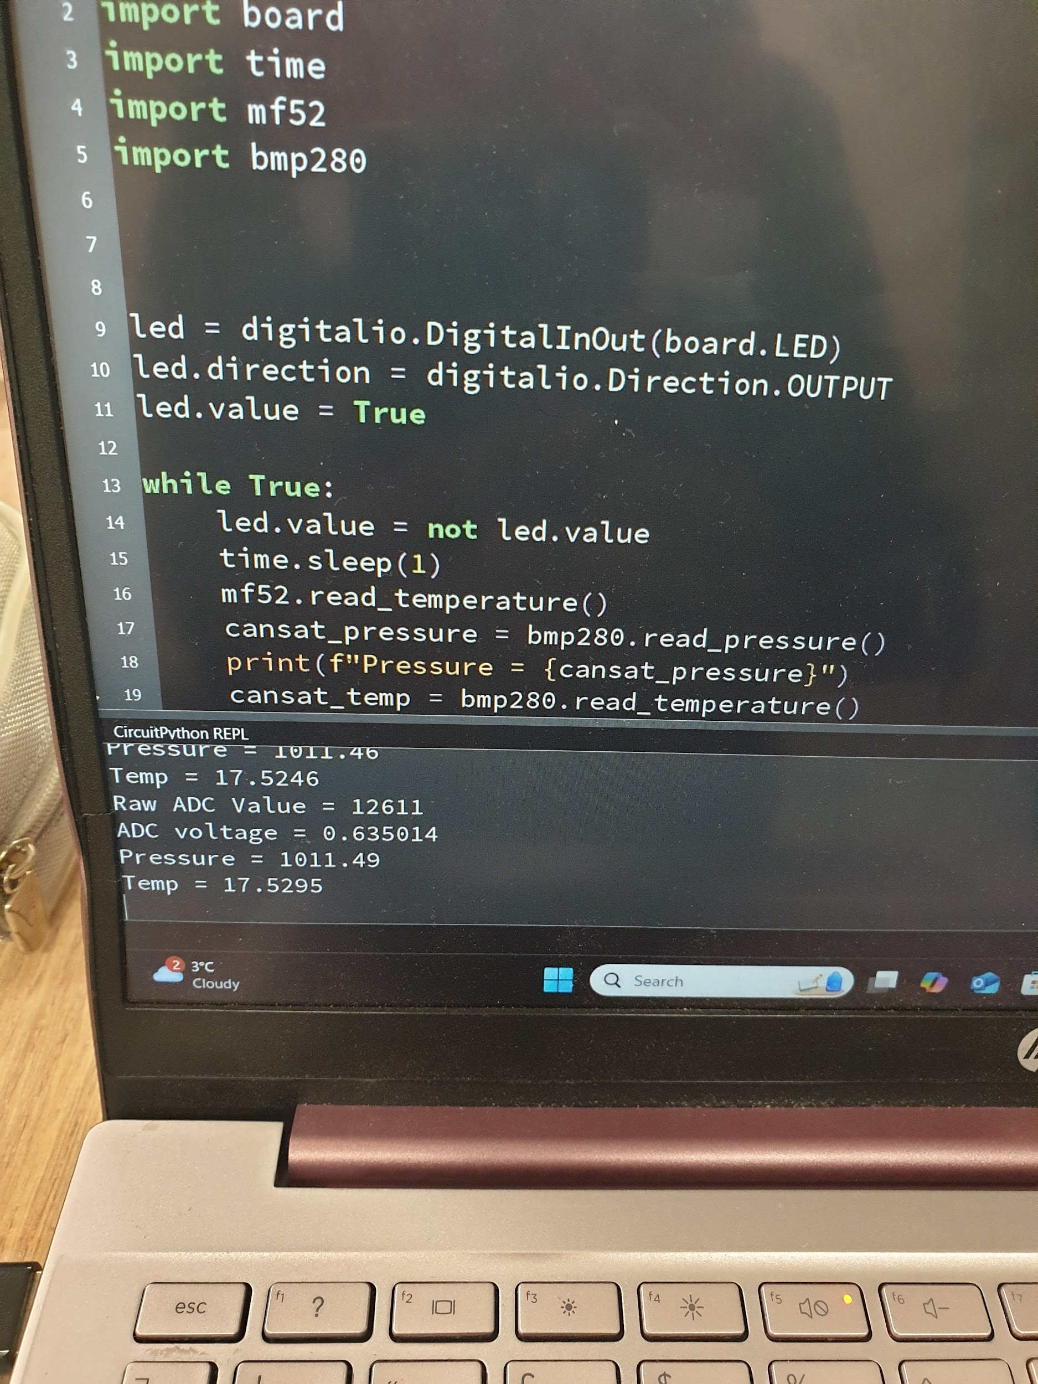

We also need a ground/radio station, and the equipment for this will be:

-Yagi antenna (at ground)

-Adafruit RFM96W LoRa 433MHz Transceiver breakout ( One at ground, one in Cansat)

We only need an antenna on the ground, for the Cansat a small wire will be sufficient

These will also be tested

1. Range test

Test status = To be tested soon

-This could be done by standing at opposite ends of an open field, or going to a team members house within 500 meters range

-This will test the capability of our antenna and transceiver in handling data over distances, and potentially also with obstacles

Criteria for success== The readings should continue to come every second even when a distance apart

1. Speed test

Test status = To be tested soon

-This could be done by attaching one transceiver (and perhaps also the BMP 280) to a drone or tethered cart and accelerating it to 10-15 m/s

-This will test the capability of our transceiver and antenna in receiving and transmitting the signals at the speeds we will face in the launch

CircuitPython and Mu will yet again be the software that we use to program our transceiver

**Secondary Mission:**

For our secondary mission, we have decided to:

-Measure the buildup of electrostatic charge during launch and descent

-Correlate this with the environmental factors (such as altitude, pressure and temperature)

**Wind-induced charge separation**: As air particles collide and move past surfaces (like the CanSat's exterior or parachute), they can create and redistribute charges.

**Humidity levels**: Higher humidity tends to dissipate charges, while lower humidity amplifies static accumulation. By correlating electrostatic data with temperature and pressure, we can better understand atmospheric conditions.

These measurements provide value as they give insight into weather conditions, especially in extreme or varied conditions (such as rain, which may come on the launch day)

Electrostatic forces are a significant consideration in spacecraft engineering:

**Surface charging in space**: Satellites and probes often get electrostatic charges due to interaction with charged particles in space. This can create problems

**Effects on electronics**: Excessive charge can lead to component failures or signal interference. Measuring electrostatic forces in our CanSat mirrors challenges faced by larger spacecraft.

These measurement are valuable because it helps simulate real world problems in aerospace engineering

Hypothesis = The electrostatic force will increase with the wind speed on the Cansat. As the CanSat ascends to a maximum height of 500m, wind speed will increase due to reduced surface friction, reaching a peak around the 300m mark, after which it will stabilize or decrease due to atmospheric pressure and temperature changes.

These readings will be done with the FDC 1004(IC, not EVB due to its huge cost), for its high precision, suitability for environmental testing available libraries and compatibility with the Pico. We have also considered other options, but they were not sufficient

-CAP 1188 = This seemed very simple to program, and cheap, but it is limited to mainly touch capacitive abilities, so it would not pick up on the electrostatic force due to wind, as we would wish.

-The MPR 121 was also an option, due to its simplicity and compatibility, but it is not as sensitive as the FDC 1004

Test status = To be tested soon

Reason:

We are awaiting the necessary equipment to test this sufficiently. However, we have detailed our testing process:

Electrostatic charge measurement testing:

-Purpose: To verify the sensors ability to measure electrostatic charge

-W have provided 2 methods:

1. Use a fan to blow over the surface at different speeds, simulating flight
2. Use materials that induce static force through friction to test the sensor

-Criteria for success= The sensor should show a change in electrostatic force at the times where it is introduced

### 1.2.2 What will you measure, why and how?

As aforementioned, for our primary mission, we will use the BMP-280 sensor to measure air pressure and temperature, and for our secondary mission, we will use the FDC-1004 sensor

We have chosen to measure the electrostatic force change as it can reveal information about weather, wind and the effect of windflow on the aircraft. Later on, we can then correlate other information such as altitude (which we can estimate accurately using the air pressure reading in relation to the average air pressure at sea level, and a built-in command in the library), and analyse the data to draw conclusions. We could also potentially plot it with the air pressure and temperature values, and see which one provides the best correlation. If we have the time and resources, we could even add more sensors such as accelerometers (such as the MPU6050)

The BMP 280 sensor can measure air pressure and temperature, with temperature at +- 1 degrees Celsius, air pressure at +- 1 hpa, and the FDC 1004 can measure electrostatic force to +- 0.5fF(femtofarad). All of these ranges will fit well within our needs, and provide a more than accurate enough reading to analyse the data

We will also plot the data on adafruit io, and have a potential program ready to add the data received from the CanSat directly to an Excel sheet. Both of these are good options

# 2 Project Planning

## 2.1 Time schedule

*A detailed project time plan which shows the tasks required to complete the project and the time (suggested to be hours required) allocated to each step. This should cover all scientific, technical and outreach tasks that need to be done and is updated with each report. A Gantt chart may be used to display this project planning. This must at least be a high-level weekly plan.*

Due to the absence of our Team Leader for 1 month for external, unavoidable reasons, we are fairly behind on schedule on the construction of the Cansat ( about 2 weeks behind the schedule we are showing). However, as we have changed the team structure to give two people to both Hardware and Software, we believe we can complete the construction of the Cansat in ample time to allow for testing and iteration as we wanted. Our slightly adjusted time plan is shown

| **Week Beginning** | **Objective** |
| --- | --- |
| 21st October | Meet and organise team members, as well as discussing skills to start to think of role distribution |
| 28th October | Assign roles based on relevant skillsets, and finalise the team |
| 4th November | Look at the design brief in detail, thinking about creative ideas. By the end of this week, we should order any necessary elements |
| 11th November | This week we should build the PDR. We will mainly assign this to the  Documentation Manager. Other members should either help, or  research and develop the skills necessary to complete their roles to the fullest |
| 18th November | PDR review by Mentor and team leader and members. The PDR will then be submitted |
| 25th November | With the elements having arrived, we should aim to start to develop skills using a breadboard and components, getting a good feel for how everything works. We should also begin to think of a basic design, using CAD software or detailed sketches for a prototype |
| 2nd December | The design in terms of shape and size was finished this week. However, we have decided to postpone the 3D printing to a very much later date after careful structural consideration (due to 3D printing’s one directional weakness), and we evaluated potential materials for the Cansat. We then decided integration and the building of the structure can be postponed till around the time of submission of the CDR |
| 9th December | This week we are going to receive the PDR feedback. For the first half, we should reflect on any critical ideas and improvements. We should then begin to assign jobs to our roles to test and start to build our Cansat |
| 16th December | Due to absence, this week was not used as much. PDR feedback was looked at and taken into consideration, for some initial thoughts towards the CDR |
| 23rd December | PDR feedback was properly observed, and we looked back at each individual section to see the problems |
| 30th December | Team members began the initial work on the primary mission, and the documentation manager began a draft for the CDR (using the PDR as a structure) |
| 6th January | The function of the primary mission and relevant testing was fully carried out. More work given to CDR |
| 13th January | The Documentation manager began to focus on the CDR, with some help on relevant sections from others in the team. Many technical elements were required. The learning for how to carry out the software and hardware for the radio/ground station was though out as well on the side |
| 20th January | The radio’s code should be completely finished, and working. Testing on the radio can begin, and the CDR should begin to be wrapped up. |
| 27th January | The CDR should be submitted to our mentor by the 29th, for him to proofread. Implementing the primary mission and radio at the same time should be tested, and parachute construction and testing can take place |
| 3rd February | The code and wiring for the secondary mission should be done, and it should be tested |
| 10th February | Carefully considering all different power consumption and more, we will wire together all electrical components of our CanSat, on a breadboard and then a pico protoboard. Then adjustments can be made |
| 17th February | We will 3D print / make the structure of our CanSat and test it, and then implement all electronic components |
| 24th February | We will implement the parachute, and do one or two fully fledged tets, then iterate on them |
| 3rd March | Repeat of last week and full preparation and plan for regional launch |
| 10th March | This week is the regional launch. Our first priority is to make sure everything goes well in the launch, ensuring everyone’s role on the day. After day, we can see our data and analyse our results. We can take improvements  from this |
| 17th March | A proper analysis and thought about the Regional launch and how it went. Based on this we should make all improvements necessary |
| 24th March | Repeat of previous week |
| 31st March | Everyone except the Documentation manager would continue to work on the improvements, but the Documentation manager will begin to start the basic structure of our FDR |
| 7th April | Some members may continue with improvements, but if we are struggling to improve our design at this point, then we may help make the FDR - this is something very difficult that we may not just leave to the Documentation Manager alone |
| 14th April | All members will work on relevant sections of the FDR. The FDR should be finished and wrapped up, and proofread by our members and mentor |
| 21st April | FDR Submitted |

We also have a Gannt chart

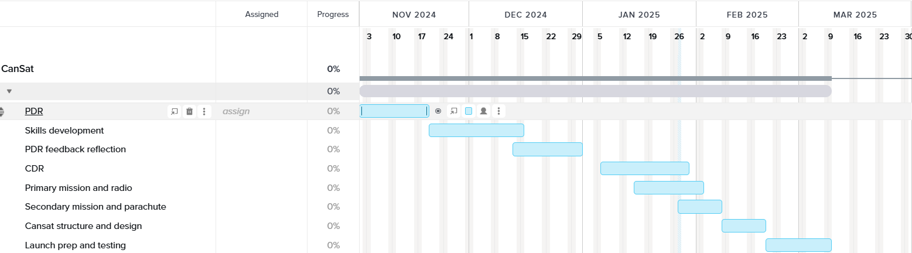

We will plan for the FDR and Nationals if we (hopefully) get in

## 2.2 Team and External Support

|  | **Programming** | **Electronics** | **Team Leading** | **Outreach** |
| --- | --- | --- | --- | --- |
| Student 1 | Has good Coding skills and knowledge of Python, but not so much in Circuit Python or Pi Pico | Has a decent knowledge and understanding of electronics concepts and has participated in SOME projects | Has experience in leading teams and enjoys being able to lead groups of people from school leadership groups | Knows how to run school assemblies, advertisement, posters and more outreach  from school  leadership groups |
| Student 2 | Has extensive Coding skills and knowledge, from a young age, with knowledge of Pi Pico | Has done numerous projects related to electronics | Is comfortable in leading a team of people, and could do a fairly good job | Has good ideas and would be suitable for the role |
| Student 3 | Has good Coding skills and knowledge of Python, but not so much in Circuit Python or Pi Pico, but is willing to learn | Has done a few projects related to electronics, but not so much | Is confident and could be a suitable leader | Has good ideas and a plan, as well as potential posters |
| Student 4 | Has decent coding skills, but not his area of expertise | Participates in many electronics projects and competitions at a time, Huge experience | Could lead the team but there are better options | Has good ideas and would be suitable for the role |
| Student 5 | Has good Coding skills and knowledge of Python, but not so much in Circuit Python or Pi Pico | Has participated in other robotics and electronics competitions such as First Tech challenge, good experience | Could lead but there are better options | Has good ideas and a plan for action |

Red = No/Little skills

Green = Amazing skills and experience

Overall, we have people with experience in all of the main, important sectors. We are slightly weak in the coding section, as everyone has experience in MicroPython, not CircuitPython, but with two people working on this, there is no real problem, and they are more than capable of learning it to the extent we need to know it in a month. For outreach and team leading, only one person in each sector is needed. Overall, external guidance will not be ended so much. Some websites could be used to gain experience in CircuitPython, but nothing else is really necessary and our team is strong

## 2.3 Risk Analysis

There are different risks for different parts of our Project. They are listed below, with mitigations

Primary mission:

* Sensor calibration errors - Testing the sensors in a controlled environment
* Environmental interference - Seal sensitive components effectively
* Microcontroller failure - Conduct extensive testing and keep a backup if possible

Secondary mission:

* Electrostatic force inaccuracies - Use a high resolution sensor
* Expensive - Go for cost effective option (FDC 1004 IC instead of EVB)
* Improper sensor placement - Think carefully about placement for optimum readings

Cansat build/structure:

* One directional weakness of 3D prints - Mitigate with electroplating or 40% infill
* Weight over/under - Weight prototypes regularly, and use suitable weight components
* Short circuits (due to vibration or wiring issues) - Secure connections and use vibration dampeners

Radio/Ground station:

* Incorrect/Busy frequency(with many other CanSats) - Tune it properly, and make sure it is not a busy channel, as many will leave it at the 433 Mhz setting
* Incorrect setup - Double check settings
* Power failure (at ground) - Bring a fully charged laptop and backup charges such as power banks

Launch day:

* Parachute deployment failure - Test parachute multiple times, and consider how the cables will undergo over 30kg of force
* Issues with CanSat - If possible, make it easier to open and edit on the day over being helpless if there are problems/it does not fit contraints

Other risks:

* Time constraints - Assign roles and keep strictly to the timeline
* Budget constraints - Monitor spending, prioritizing critical components
* Documentation errors/miscommunication - Double check for accuracy with the whole team

# 3 Cansat Design

## 3.1 Mechanical design

Idea 1: Internal support:

-Due to large amount of force exerted on the Cansat, we want the components to survive up to 30G

-Therefore, due to the inclusion of sensors and electronics, it will require protection

-There are a few forms to choose from:

1. 3D printed beams + Rigid structure

-Using the school or another 3D printer, we could create beams to provide structural support and keep the components in place

-These should be light and not obstruct any function of the sensors or electronics

-These could make it much easier to assemble and

1. Padding

-Using some form of soft material such as a fabric we could provide padding to sensitive areas

-This could however obstruct the function of the sensors, mainly the electrostatic one

We will include a rigid structure with support beams, as if well designed it can be lightweight, easy to work with and not be an obstruction. Padding will be used sparingly in specific sections where needed most, as well as to prevent vibrations

Idea 2: Perforated surface

Benefits:

-Weight is a constraint of our project, so any way to reduce the amount of material used is great

-It provides an airflow, which can:

-Regulate temperature of electrical components

-Provide more data for our secondary mission, to measure electrostatic force

-!?Could Provide holes to slide wires through!? (a more creative use)

Material wise, we will use our school’s 3D printer. Due to our limited experience, we will go with what our DT teachers suggest. This is likely to be a strong form of plastic such as Polycarbonate or ABS. As well as this, due to 3D printed material’s one directional weakness, we will either electroplate or infill the print, but are leaning towards a Zinc electroplating, due to available resources, and one of our team member’s experience. This could, however, dissipate the electrostatic force, or even worse, create a sort of Faraday cage, preventing us from detecting any static force at all. However, to combat this, we will cover the CanSat with a spray on rubber coating, or coat it with any other good insulator.

Here is an orthographic sketch:

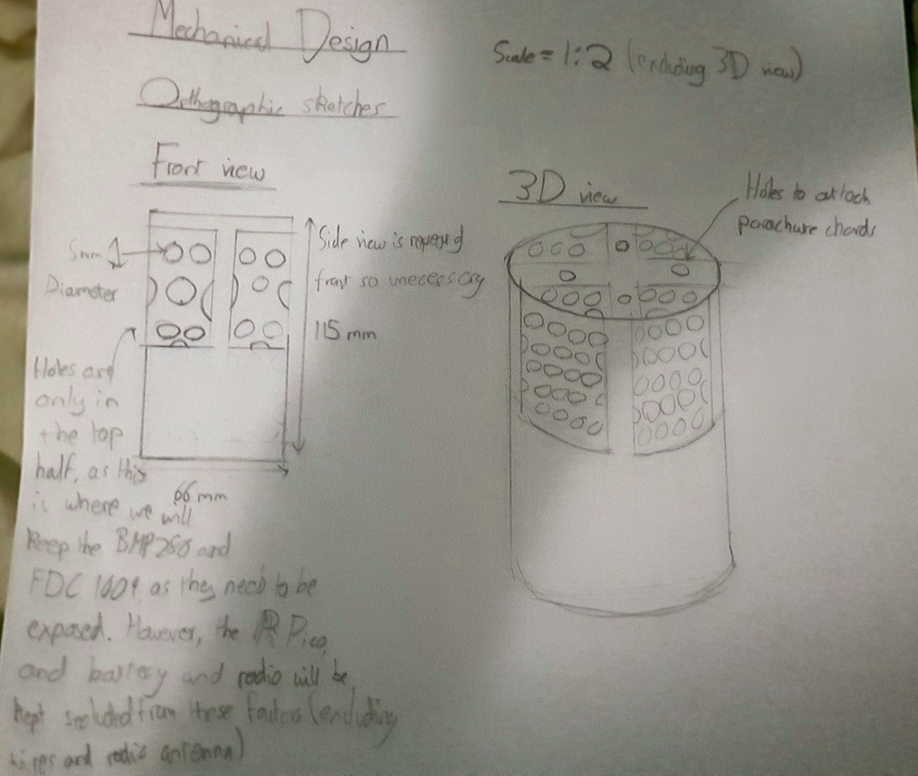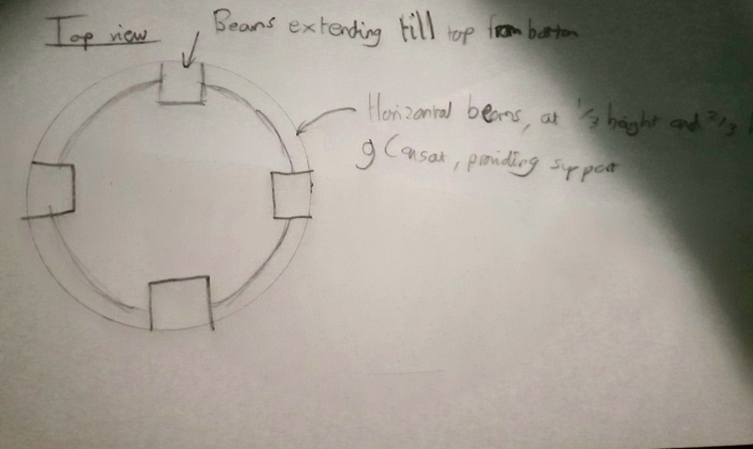

CAD design with side, top and 3D view(Does not include the internal beams and holes on top but overall good for our little experience with the software):

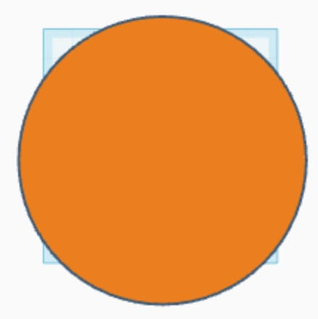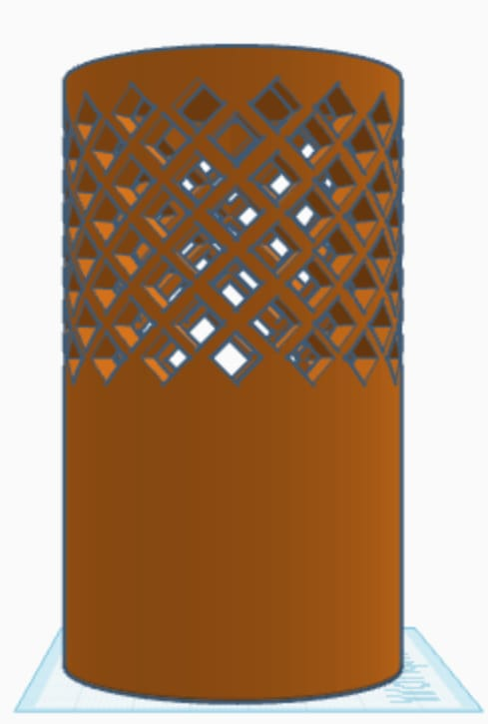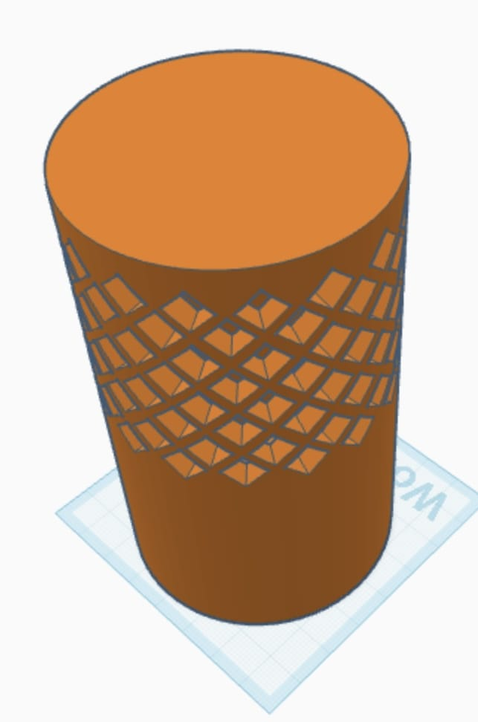

We have also started on prototypes of our CanSat model. However, we have first used a 3D print of last year's CERC team. This is because they had a successful launch, and we can then see how the components fit in. This is because we believe the printing of our design is a secondary issue that can be done and tested in a shorter period of time, as well as due to the absence of the team leader for a few weeks. However, a detailed sketch, and a full plan has been provided, as well as a CAD design being made( in a way that it is suitable for 3D printing, not just design purposes). As soon as we are able to access our school’s 3D printer and we are happy with the model, the whole process of electroplating, structural support, padding, electroplating and testing will be done in one or two weeks on the side, by the hardware team, where the software team will ready the primary mission, secondary mission and radio station such that assembly is a one or two day process.

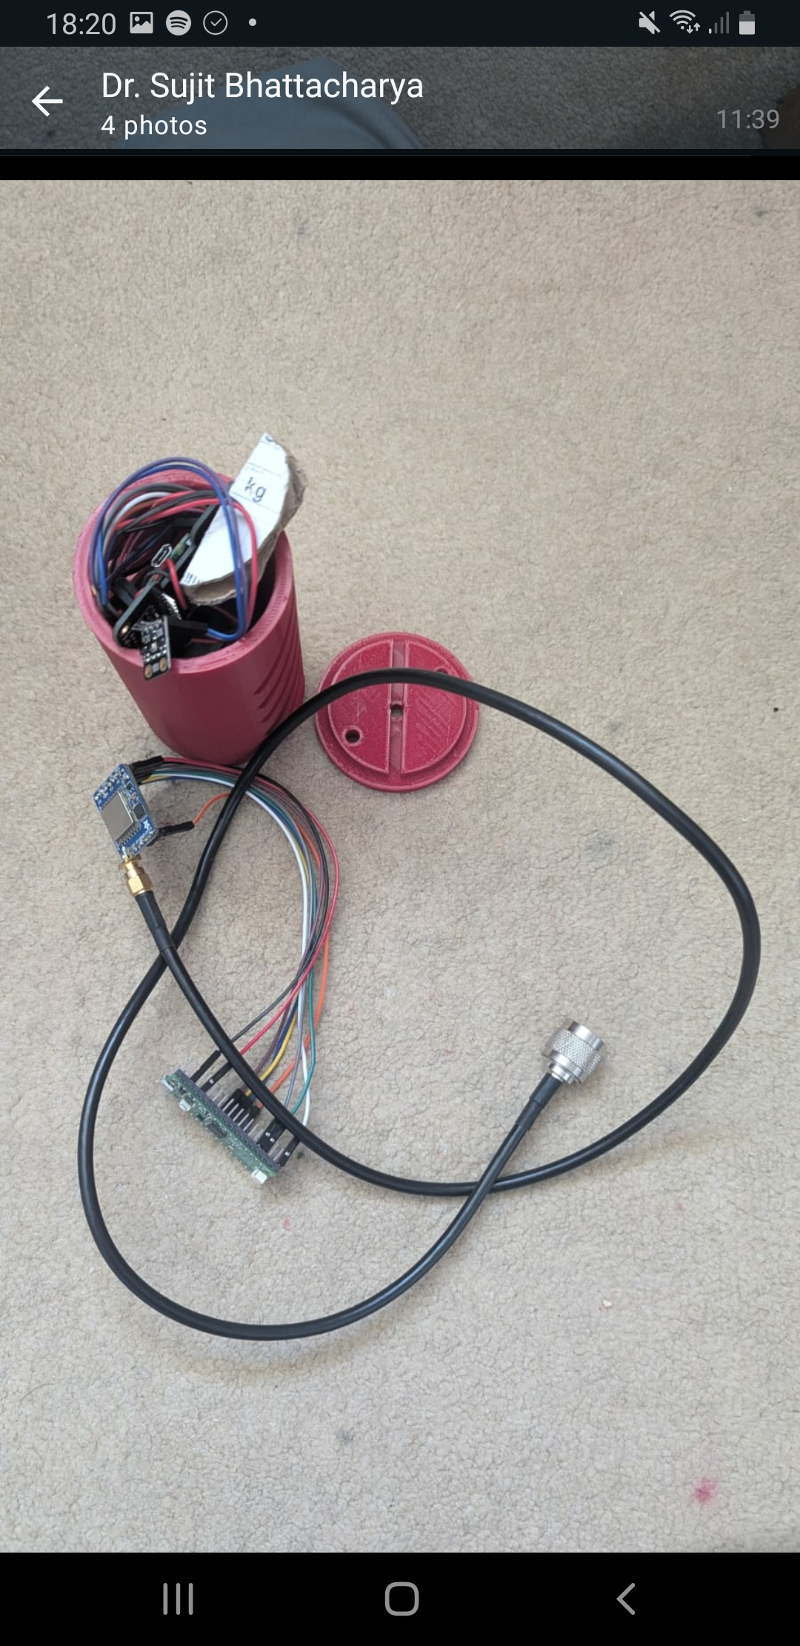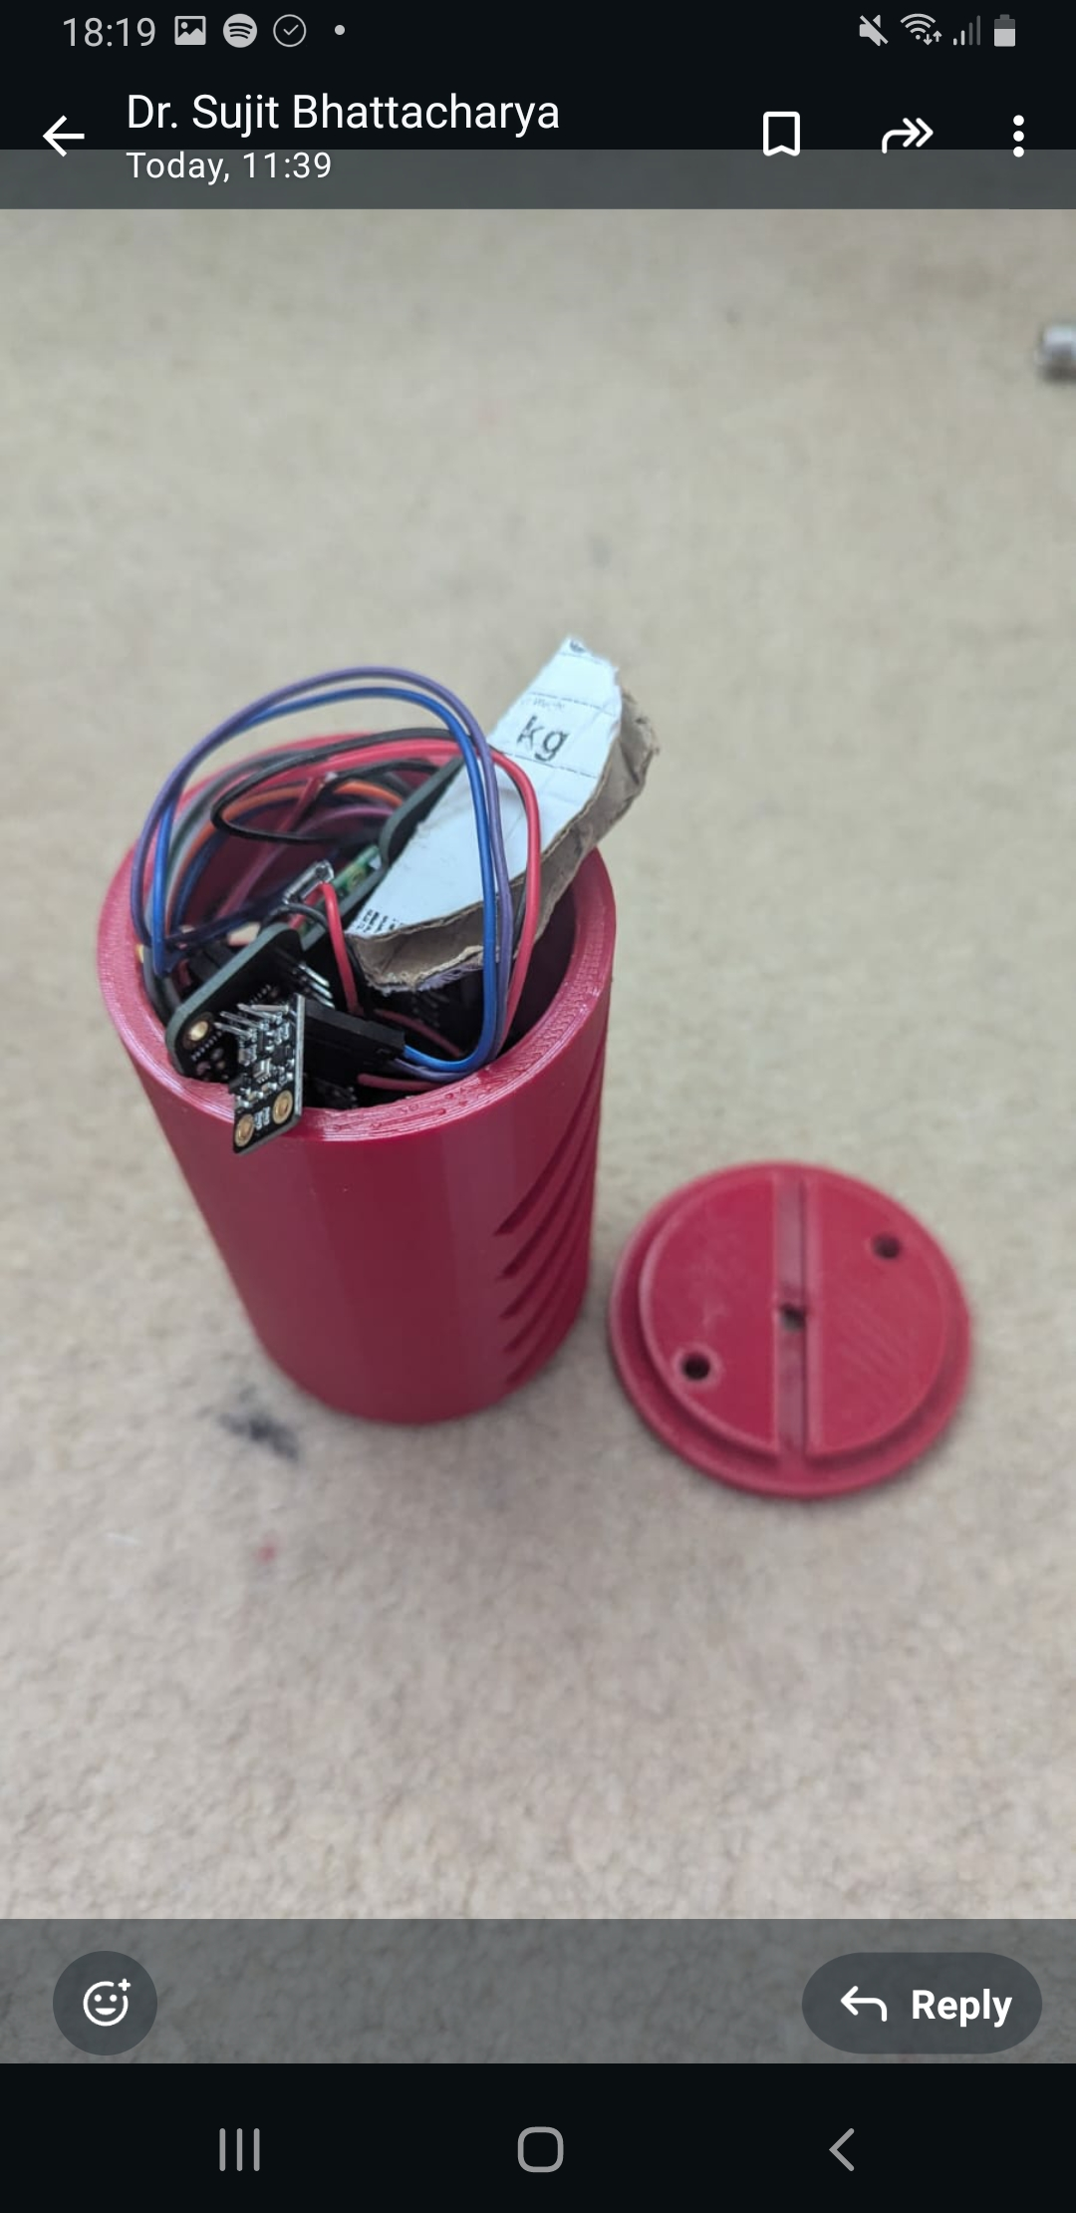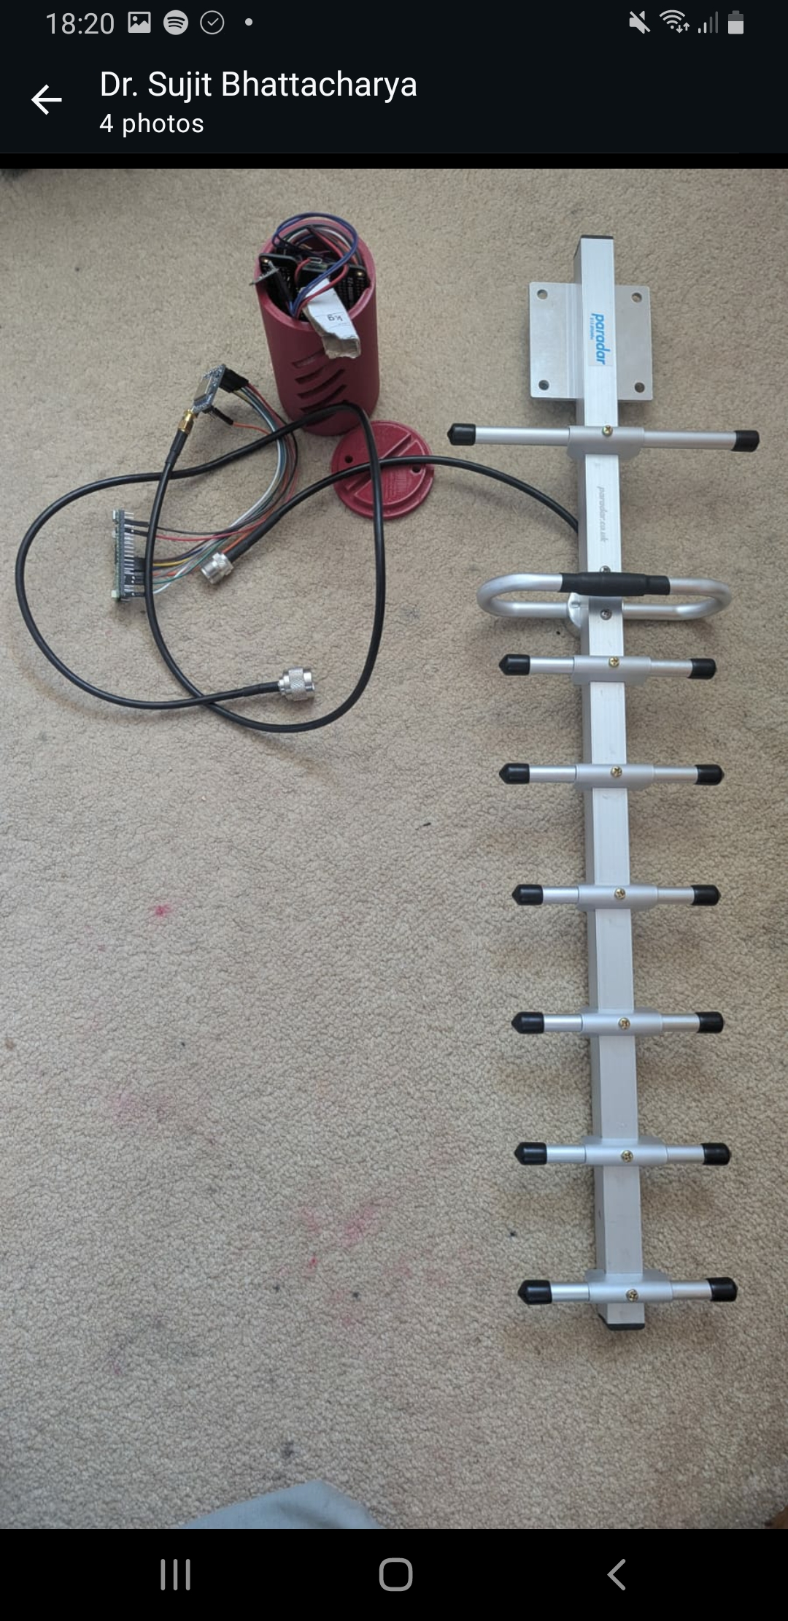

## 3.2 Electrical design

Micro controller:

-For our Microcontroller, we have gone for the Raspberry Pi Pico

-It has a form factor of 21mm x 51mm

-Reason: This will come with our CanSat kit, and was recommended by our mentor, who has extensive experience with it.

Primary Mission sensor:

-For our Primary mission sensor, we have gone with the BMP280 breakout (form factor = 20mm*20mm*5mm), as aforementioned

-This is due to its high accuracy, its low weight, compact size and the fact that this was suggested by our mentor, and comes in the kit

-This could also measure the altitude, to trigger many things such as the servo for a potential second parachute, and gives us a variable to plot the electrostatic charge against

Secondary mission sensor:

-For our secondary mission sensor, we have gone with the FDC 1004 sensor to measure electrostatic force

-This is a touch capacitive sensor, which can measure the presence of electrostatic charge.

-This is a very small and lightweight sensor, so it will easily fit into the design.

Picture of circuit diagrams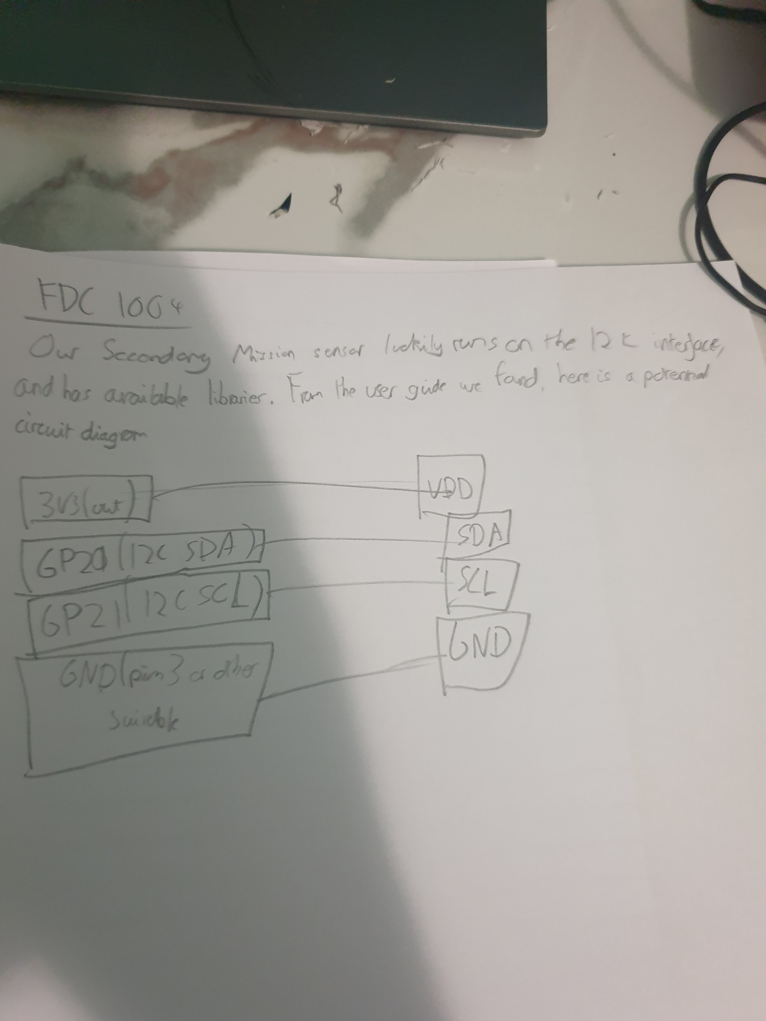

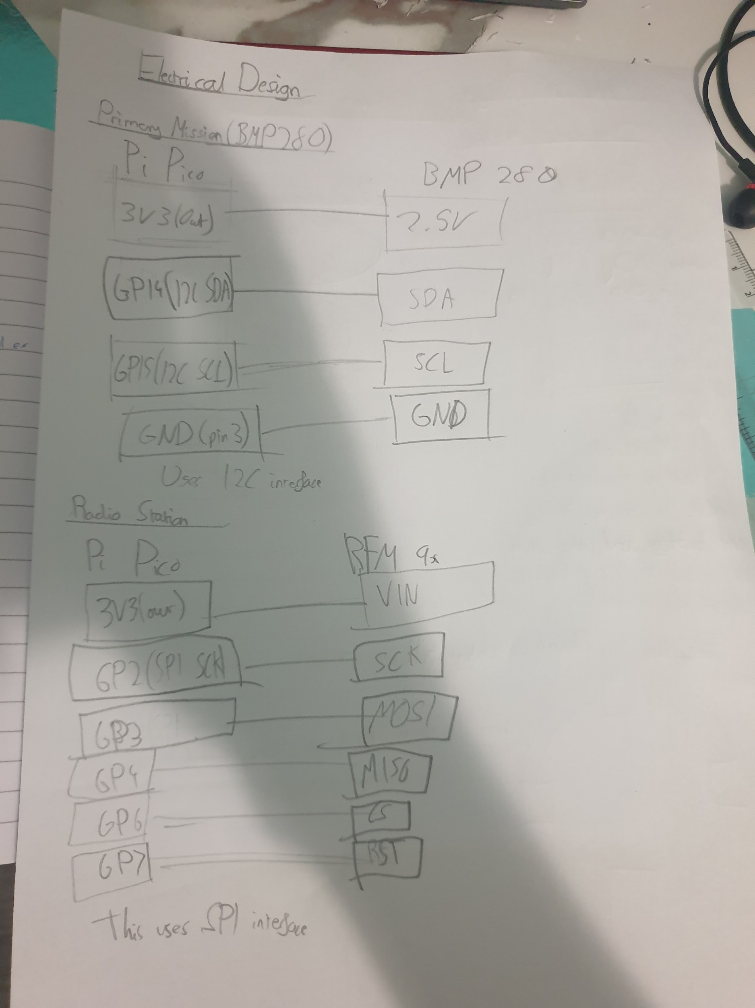

Here is the wiring of our RFM9x and the BMP 280:

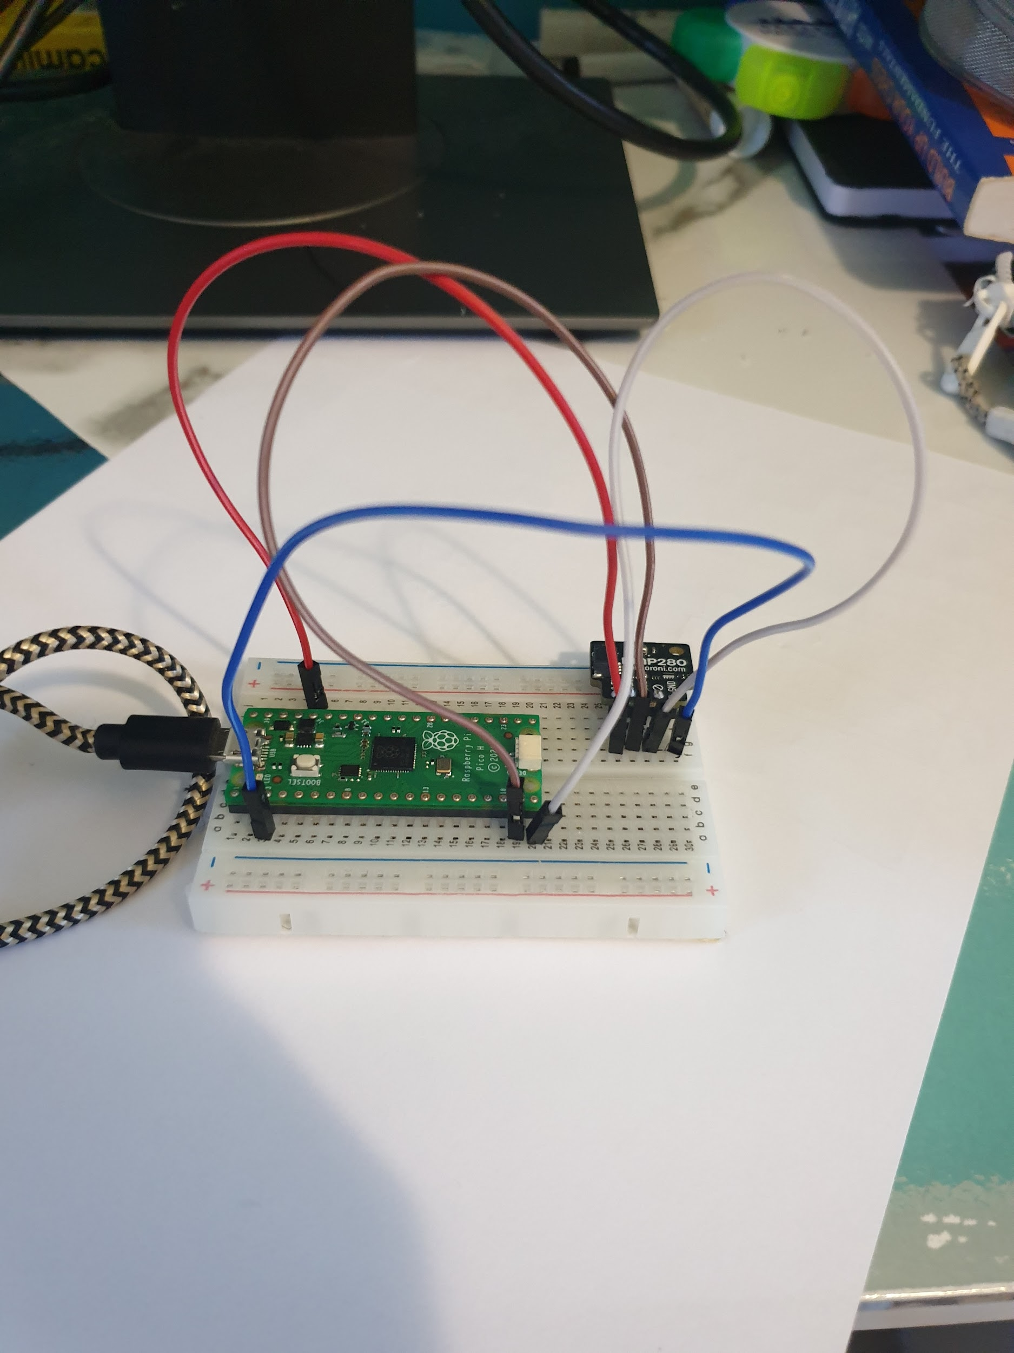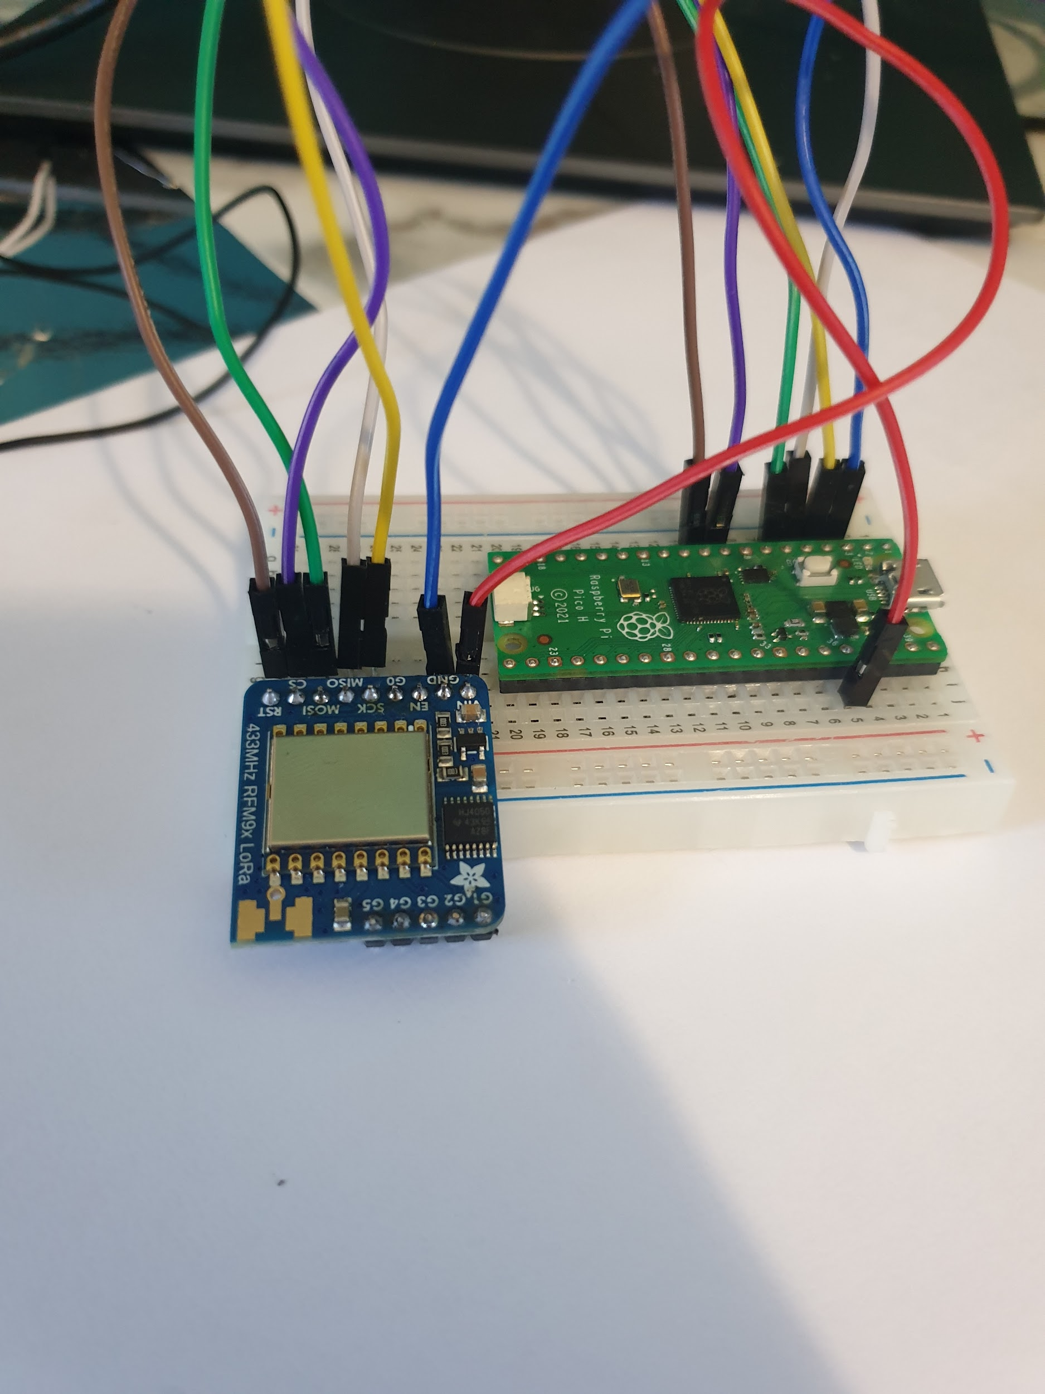

## 3.3 Software design

Software wise, we have decided to use Python due to its massive cope for flexibility and its simplicity and easy syntax.Initially, we though that we will be using the Micro Python IDE as two members of our team already have experience with the environment. However, it is not as suitable for our mission as Circuit Python. Therefore, we have switched. This is mainly based on advice it the CanSat workbook provided in the Kit list

As well as this, we will need software for our data analysis. It is likely that for this Adafruit io will be used, which is specifically made for data collection. This library is also familiar, for some team members and our mentor, which makes it a good choice

We have written code for our BMP 280 and our RMF9x. Here they are

BMP 280:

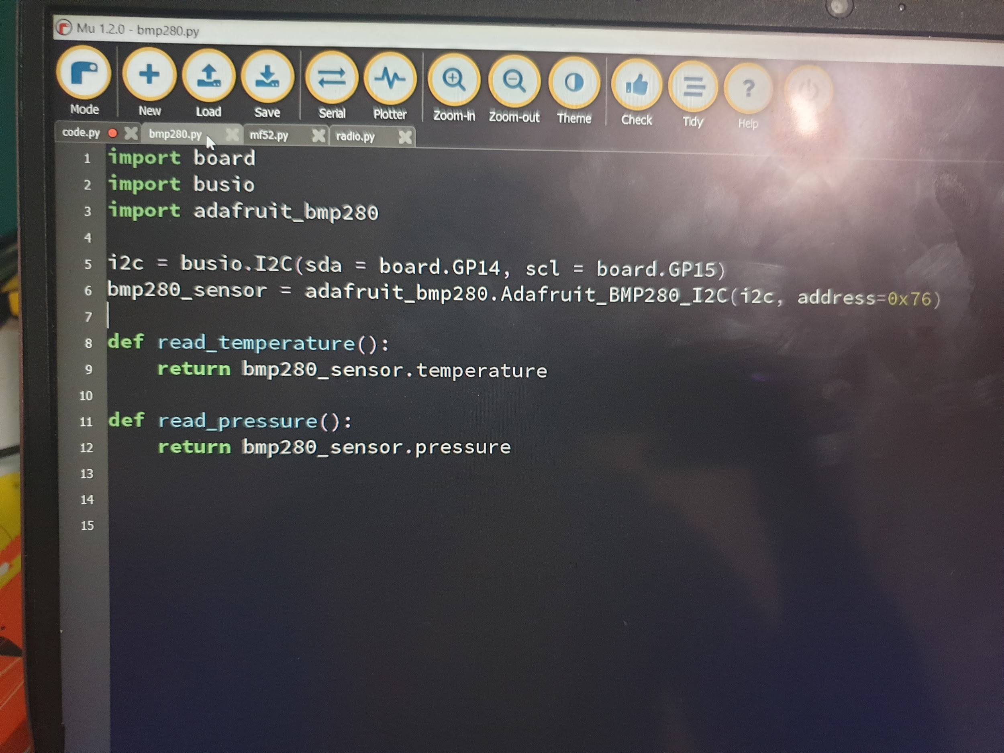

RFM9x:

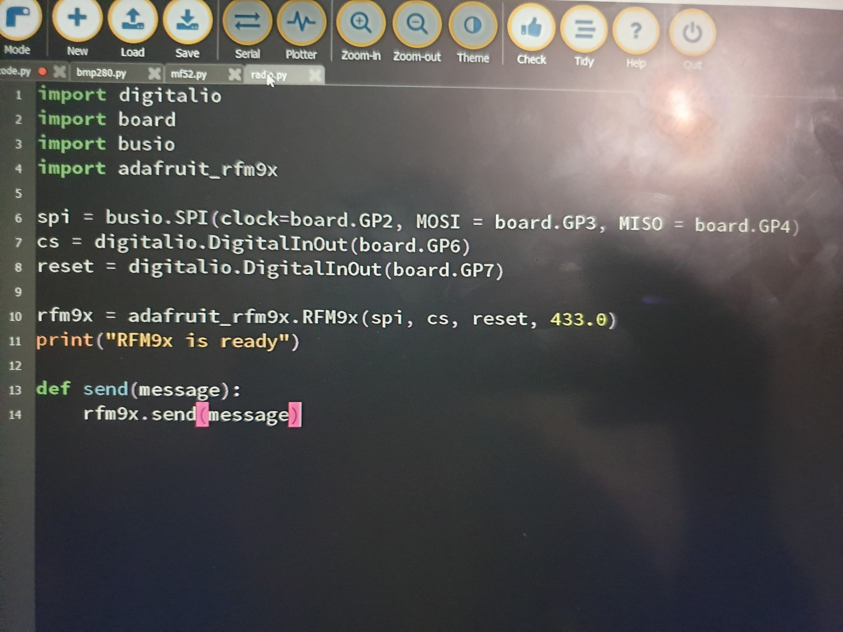

Main code section:

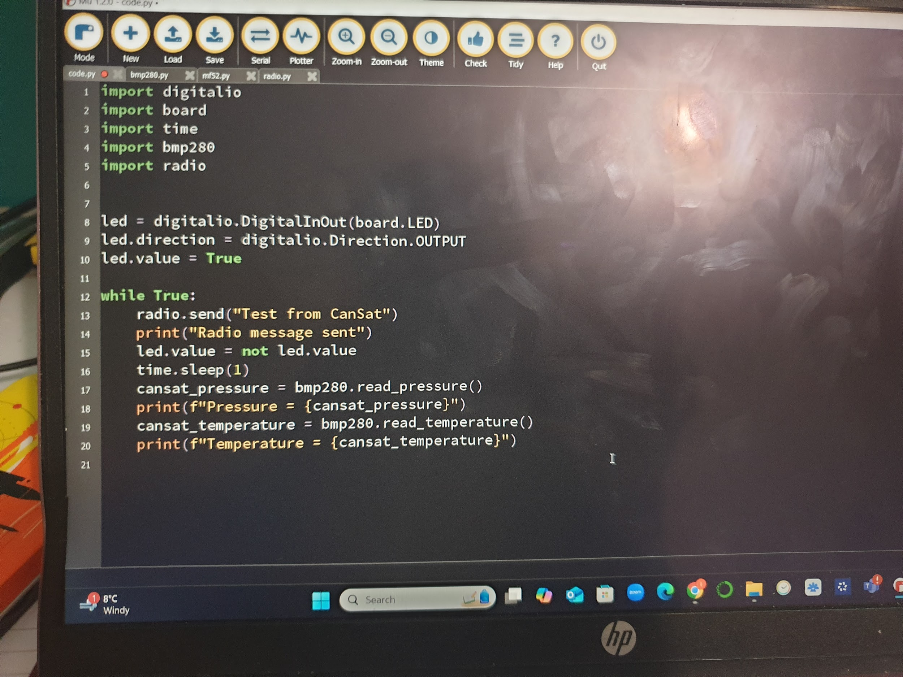

We have not yet started to write code for the FDC 1004 as we do not have it yet. However, we do have the user guide (which will be included in the appendix).

## 3.4 Landing and recovery system

Objective: To be able to provide a steady descent rate between 10 and 15 m/s, whilst providing the stability necessary for accurate and relevant readings

Shape:

There are multiple options that we have looked at:

1. Circular

-Drag Coefficient = 0.8 → Moderate descent speed

-High stability with minimal oscillation

-Pros = Simple and reliable

-Cons = May wobble in rough weather /high wind

1. Hexagonal

-Drag coefficient = 0.8 → Moderate descent speed

-High stability and good balance

-Pros= Slightly better control

-Cons= Potentially complex to attach lines to

1. Cruciform

-Drag coefficient = 0.7 → Moderate descent speed

-Very high stability and minimal spinning

-Pros= High stability in almost all weather/wind

-Cons= Very complex to build, more material used

We have chosen the Hexagon, as it is not too difficult to make and provides stability.

Size:

This is calculated using specific equations involving the desired descent speed, the drag coefficient and so on. As we want our CanSat not be affected by a dangerously fast descent time, we have kept it to 10 m/s

We will use the drag force, or "wind resistance force" equation, which is:

FD = ½ p Cd A v2

And the weight of the rocket is:

FG = m g

When the force of gravity is equal to the air resistance force, we will get a constant speed. Therefore, we get

FG =FD

m g = ½ p Cd A v2

And to solve for area, we get:

A = (2 m g) / (p Cd v2)

Let us now substitute in the values.

Mass = 300-350. We assume the mean of 325g

G = 9.8 m/s^2

P = 1.22 kg/m^3

Cd = 0.7 (For a hexagonal parachute, this is typical)

V2 = (10 m/s)^2 = 100 m/s

This gives us:

A = ( 2 * 0.325kg * 9.8 m/s)/ (1.22 kg/m^3 * 0.7 * 100m/s)

This simplifies down to 745.9016 cm^2.

As it is a hexagon, using the necessary calculations:

We get a diameter of roughly 34cm, and a side length of roughly 17cm

This gives us the dimensions of our parachute

Material:

-The material needs to be lightweight and durable

-This is why we have chosen nylon, for its high strength to weight ratio.

-We will also use a reinforced, strong material such as Kevlar or Nylon threaded through the perforated surface of our CanSat to ensure good attachment. Each cord should be able to take 30 kg, due to the high force when it is forced out of the rocket. This will be tested, to make sure no cords snap

Deployment:

-The parachute should not tangle or tear during deployment, and needs to open fully.

-However, seeing how commercial parachutes do not require so much attention in deployment and the simplicity of it, we will only use passive release compared to a servo

-Folding the parachute and testing which way minimizes the risk of tangling is a fair way to go about this

-Using a servo and compartment would actually increase the chances of the parachute not deploying, so we eliminated this idea

-As well as this, we are using a spill hole to reduce oscillation

-This will be kept at around 20% of the area, to minimise its effect on our calculations

-Online sources such as websites designed for the purpose of these calculations could be used to adjust if necessary, but this is unlikely at this point, and construction will likely begin the next 2 weeks

Drop test:

-Purpose: To test how well the parachute works and if it works at the right speed

-This could be done by adding a weight (within the constraints), and then dropping it from a height

-Criteria for success= The parachute should remain stable and drop at the expected rate of 10m/s.

Risks:

-Tangling is a major risk that would affect the stability and descent rate of our parachute. As we are choosing passive descent, when packed we will take great care in our folds to make sure no wires cross over.

-Another risk is our parachute not deploying. For this, we could potentially add a backup that would be triggered at some late stage such as when the Cansat would be at an altitude of 100m (assuming no parachute). However, due to complexity of servos, and the potential to overdesign, we have opted out of this. It is better to go for a simple design that works 95% of the time than a complex one that works 80% of the time. A good amount of testing is all we need

## 3.5 Ground support equipment

The ground support equipment (GSE) is critical for the successful operation, data retrieval, and monitoring of the CanSat during its flight. Our setup integrates a Yagi antenna with the Adafruit RFM9x LoRa Transceiver for reliable communication between the CanSat and the ground station. The following points elaborate on the integration, functionality, and radio capabilities of our GSE.

#### 

1. Data Transmission:  
   The RFM9x transceiver onboard the CanSat is configured to send telemetry data (e.g., temperature, pressure, and electrostatic force) to the ground station in real-time. The Yagi antenna, with its directional capabilities, ensures the signal is strong and focused for long-range reception.
2. Setup:  
   The GSE includes a laptop, the Yagi antenna mounted on a tripod, and the LoRa receiver module connected to the laptop via USB. Custom software (written in Python) is used to decode and visualize incoming telemetry data.
3. Alignment:  
   The Yagi antenna requires precise alignment with the CanSat during its descent for optimal signal reception. We will actively adjust the antenna's direction based on pre-calculated flight paths and telemetry data.

#### Integration with CanSat

#### 

1. Data Transmission:  
   The RFM9x transceiver onboard the CanSat is configured to send telemetry data (e.g., temperature, pressure, and electrostatic force) to the ground station in real-time. The Yagi antenna, with its directional capabilities, ensures the signal is strong and focused for long-range reception.
2. Setup:  
   The GSE includes a laptop, the Yagi antenna mounted on a tripod, and the LoRa receiver module connected to the laptop via USB. Custom software (written in Python) is used to decode and visualize incoming telemetry data.
3. Alignment:  
   The Yagi antenna requires precise alignment with the CanSat during its descent for optimal signal reception. We will actively adjust the antenna's direction based on pre-calculated flight paths and telemetry data.
4. Frequency Tuning:  
   To avoid interference with other communication channels in the area, we have programmed the RFM9x transceiver to operate on a less crowded frequency band within the permissible 433 MHz range. Manual adjustments to the signal frequency will be made if necessary, depending on real-time conditions. This is also mentioned in mechanical design section
5. Testing:  
   Prior to launch, the CanSat and ground station will be tested together to ensure seamless communication. This includes range tests, ensuring the CanSat can send clear signals at distances up to 1 km under ideal conditions.
6. Power Management:  
   Both the CanSat and the GSE rely on fully charged power supplies. The CanSat will use a lightweight battery pack, while the laptop and receiver will rely on external battery backups to prevent power failure during the mission.

#### Radio Capabilities

1. Long-Range Communication:  
   The RFM9x LoRa transceiver, paired with the Yagi antenna will provide a reliable communication link with a range of several kilometers, ensuring data retrieval even during high-altitude and descent phases.
2. Directional Focus:  
   The Yagi antenna’s high gain and narrow beamwidth allow for focused signal reception, reducing interference and improving data clarity.
3. Frequency Adjustment:  
   Our system is designed to change transmission channels slightly within the allowed frequency band to avoid busy channels and reduce potential interference from nearby devices or other teams.

#### Operational Ideas

1. Power Backup:  
   We will ensure all laptops and backup batteries are fully charged before launch day to avoid interruptions in data collection
2. Signal Monitoring:  
   A dedicated team member will monitor the signal strength and telemetry data during the mission. In case of weak signals, adjustments will be made to the antenna’s direction or frequency.
3. Post-Launch Data Retrieval:  
   Data logs will be saved and backed up immediately after the mission to prevent loss and allow for post-flight analysis.

## 3.6 Testing

The CanSat hardware and missions must be designed to the following requirements and constraints:

1. All the components of the CanSat must fit inside a standard soda can (115 mm height and 66 mm diameter), with the exception of the parachute. An exemption can be made for radio antennas and GPS antennas, which can be mounted externally (on the top or bottom of the can, not on the sides), based on the design
2. The antennas, transducers and other elements of the CanSat cannot extend beyond the can’s diameter until it has left the launch vehicle
3. The mass of the CanSat must be between 300 g and 350 g. CanSats that are lighter must take additional ballast with them to reach the 300 g mass limit required
4. Explosives, detonators, pyrotechnics, and flammable or dangerous materials are strictly forbidden. All materials used must be safe for the personnel, the equipment and the environment. Material Safety Data Sheets (MSDS) will be requested in case of doubt
5. The CanSat must be powered by a battery and/or solar panels. It must be possible for the systems to be switched on for three continuous hours
6. The battery must be easily accessible in case it has to be replaced or recharged in the field.
7. The CanSat must have an easily accessible master power switch The CanSat should have a recovery system, such as a parachute, which is able to be reused after launch. It is recommended to use bright coloured fabric, which will facilitate recovery of the CanSat after landing. It is forbidden to convert the CanSat into a motorised drone or motorised paraglider on ejection from the rocket.
8. The parachute connection must be able to withstand up to 50N of force. The strength of the parachute must be tested, to give confidence that the system will operate nominally.
9. A descent rate of around 10-15 ms-1 is recommended. At a minimum the descent speed should be 10 ms-1 but please be aware that the launch provider may request that the parachute is replaced by a smaller one. The launch provider checks all parachutes before launch and will insist on replacement of incorrectly sized parachutes (spare parachutes are provided at launches).
10. The CanSat must be able to withstand an acceleration of up to 20g for rocket launch
11. The recovery of the CanSat is not guaranteed after the launch

For each of these, we have a test:

1. Whilst electroplating and adding the rubber coating, we will constantly check the lengths, especially the diameter, to ensure that we can launch on the day
2. We will not design this into our CanSat.
3. When adding the components, we should constantly check and monitor the mass. Although on the day they will give weight if it is underweight, it is better for our design to make sure it is already heavy/light enough
4. We will not include this in our design
5. We will have a test with our fully built CanSat turned on and continuously sending data for at least 3 hours, to ensure the battery and electrical system’s capability
6. When we 3D print our design, we will make the top screw on/removable to easily access the inside
7. We will incorporate a master switch, near our battery, accessible in the same way
8. We will make sure each parachute connection can take at least 30kg of mass
9. We will test our parachute with a mass similar to the CanSat, throw it from a tall building or drop it from a drone and test the correct descent speed. We will also do this test with the fully functional CanSat
10. We will add vibration dampeners and padding, and make sure that all internal components are tightly secured and unable to shake, to make sure they do not break/break free during launch

Most tests cannot be done without our fully operational CanSat, which will be made 2 weeks before the launch, and so we will not have test results before the CDR submission

## 3.7 Overall testing for launch

Most such tests are provided in the relevant sections. However, this will include a more detailed description of our test/simulation of a launch day

We will first attach our CanSat with the parachute to a drone. This will be brought to an altitude of 250m. The CanSat will then be dropped. All relevant ground equipment will also be present, so we will see if the data is being received and collected, as well as if the parachute is working within the wanted speed. All possible data and issues will be pulled out of these tests, to iterate on and improve our CanSat

## 3.8 Evidence of CanSat build

*Photos are included in our Electrical and mechanical design section, and the code in the software section. We have not started on the actual structure, because we think it is easy to test with a print of last year’s team’s model, and making our own and integrating the components in ours should be easy after we know where everything should go*

# 4 Outreach programme

For our outreach, there are many ideas we have. They are listed below

Local Newspaper:

There is a local newspaper which has collaborated with our local electronics and Robotics Club multiple times to raise awareness of competitions such as Pi Wars. With our mentor, this would be an easy form of media to advertise our team to our local people. As well as this, many younger students from Primary and the lower years of Secondary do not have much access to phones and social media, so this is an easy way to reach them. This will be done **after** the regional launch, when we could show them lots of our work

School assemblies:

Our school is very accommodating, and has had assemblies on many different topics, and many by students. Our local electronics and robotics club has also held an assembly with them in the past. By asking our heads of years and teachers, we could organise an assembly where we talk about this competition, and the skills it has helped us develop. This would help all of our peers be informed about such opportunities. **This is best done after the regional launch, as we will have engaging videos and photos to show, compared to just pictures and prototypes. This will be more interesting to those generally not involved in STEM activities**

Social media:

The Robotics club that has been mentioned before has a respectable social media presence. Using this, we could advertise our design and the competition to a far bigger pool of people, raising awareness not just locally. In hindsight, this could have been done earlier, but due to the Team Leader’s absence and our general lack of use and experience with social media, this is unlikely to occur, and would only be one or two videos of the Regional Launch

Workshops:

We also run workshops in our robotics club fairly often, where members of the public are encouraged to join. Here, at a later stage we could show our design, raising curiosity and interest in the local public. This would also be a great way to spread our acquired knowledge and skills. This could have been done earlier, but our Team Leader’s absence meant that we did not have the time. This will be conducted at some point after the CDR submission date

Although we have been unable to conduct any outreach, we have a solid and strong plan to spread awareness. As well as this, we would like to do most of it **after** the regional launch, as this gives us videos and photos that would be more engaging than just pictures of prototypes, documentation and very simple programs (e.g. our BMP280 program). Although we will not be able to share any results or statistics on our outreach, we believe this is the best approach to spread awareness and interest in STEM activities.

# 5 LAUNCH DAY PREPARATION

## 5.1 Launch checklist/countdown

*Here is a timewise checklist. Durations given by time on left, if no person mentioned assume all team members:*

*Launch prep:*

* 9:00 : Arrival at site. Check we have all components and equipment. All team members
* 9:10: Unpacking equipment. Team leader and hardware developers carefully remove CanSat and Yagi antenna, whilst software developers set up laptop
* 9:20: Assemble ground station. Mount the antenna, face it in the direction of launch and connect the transceiver to the laptop.
* 9:35: Turn on power, and verify the receiving of data, as well as the laptop and backup batteries. Make necessary adjustments
* 9:45: Final checks. Ensure Sensors are working, check battery levels, Ensure parachute is tightly packed, inspect for damage
* 9:55: Configure and test frequency
* 10:00: Give CanSat to officials
* 10:05: Align antenna, and check that laptop is ready for the telemetry signals
* 10:15: Observe launch

During descent and ascent:

* Team leader and 1 hardware developer: Use antenna and receive the data, make adjustments if necessary
* Software engineers: Use laptop to analyse and effectively record the data in Excel or Adafruit io
* 1 hardware developer: Check visual trajectory of CanSat to estimate where to go to recover

## 5.2 Post mission checklist

After landing:

* 10:25: Recovery phase, try to find CanSat in field, will be a bright colour like Neon orange or pink
* 10:45: Post recovery, try to collect the data from the CanSat and then turn it off
* 11:00: Wrap up, pack up and head to minibus
* 11:15: Debrief by team lead, discussion on results and potential improvements for next time

## 5.3 Launch Day risk log

Each section is listed with risks, impact and mitigations

Parachute:

* Weak shroud lines; shroud lines snap and CanSat freefalls; Use strong, thick chords of Nylon or preferably Kevlar
* Weak attachment points; parachute detaches; use strong connections, like threaded steel rods and large washers
* Parachute tangling; Reduced drag and near freefall; test multiple times and adjust accordingly

Structure:

* Weakness of 3D designs; Damage/breaking sustained during launch; Correct orientation and electroplating
* Unsecured mass; Moving heavy mass like battery causing internal destruction; Strongly secure all elements with bracket, padding and straps suitable for High Gs
* Oversize CanSat; No launch :( ; Ensure within the 66-115mm constraint, including protrusions

Ground support:

* Frequency issues; interference with other teams;
* Power issues; Loss of power when needed,insufficient data collection; Charge everything and bring backup batteries
* Lost components: Bring backups of key components and double check using the checklist

Launch day logistics:

* Dull coloured CanSat;unable to recover and reuse expensive components; Make it a bright colour like Neon orange
* Insufficient testing; Sensor/Component failure on the day; Conduct outdoor testing of full CanSat system before launch
* Late arrival; Less time for last minute adjustments and fixes; arrive on time

Appendix

User guide for FDC1004: <https://www.ti.com/lit/ds/symlink/fdc1004.pdf?ts=1737973890012&ref_url=https%253A%252F%252Fwww.mouser.de%252F>

Hexagon calculations: <https://www.omnicalculator.com/math/hexagon> (could be done without this as hexagon = 6 equilateral triangles, but unnecessary to waste time when we have resources)